Today’s British Journeyman
Being awarded a Fellowship from The Winston Churchill Memorial Trust this year has been a life changing experience. My project, ‘Regeneration for the British Blacksmith Journeyman’, has manifested in many forms, therefore within this report I will explain the ethos and the extended results of my work. I am proud and grateful for the opportunities I have been given in order to help my own practice and to benefit the blacksmithing community and craft. My Fellowship Report is as follows…
There was an old man sat on a donkey with his son walking beside them. Some people pass by and comment on how unfair it was for the old man to be sat on the donkey whilst leaving his son to do the walking. Further along the way they swap over and the son takes to riding the donkey and the old man walks. More people pass by and this time comment on how unfair it is for the son to be sat on the donkey whilst leaving his poor old father to walk. Further on still and both the old man and the son decide they would both ride on the donkey and along comes another group of people who then comment on how unfair both the father and son were to be sat on top of the poor donkey.
I believe the information I am compiling about journeymanships will be subject to many different views and perspectives. The very essence of these kinds of projects cannot please everyone initially. However, in clarifying this point I ask you to read this with an open mind and hope to demonstrate its potential.
Since the Iron Age, the versatile process of forging has been utilized in a vast array of applications. This adaptability has been key to the success and the survival of the blacksmiths craft throughout history. Today the forging process is still being used in heavy industrial work aided by large machines and advanced technologies. There is also a relatively small industry of blacksmiths working in a variety of specialist areas. They make different types of work within the fields of architecture, restoration and conservation, design and domestic, to Art and industrial production. These blacksmiths are custodians of the craft skills and their work is testament to the deep resonance that comes from this ancient process.
My name is Jack Waygood and I have been training within the field of Artist Blacksmithing for ten years. From a young age I wanted to be an artist and I’ve always wanted my work to become useful to people in some way, shape or form. By giving this insight into my own career choices, I’m trying to create an example of today’s routes into blacksmithing with focus on journeymanships. I have also been collecting stories from blacksmiths who have chosen a similar path and hope to reinforce the notion of a working, traveling and learning scene which is very much alive and well.
In formal education I started off on a BTEC in Art and Design at Manchester City College. I thoroughly enjoyed the freedom of exploring and experimenting, with an emphasis on creativity. In 2009, I then moved to Herefordshire and studied on the ‘BA’ in ‘Artist Blacksmithing’ course. This is the only degree of its type and is offered by Hereford College of Arts, which has now become an internationally recognized university for the artistically combined forging process. At the beginning of the course, I quickly became frustrated by my skills as a craftsman and turned my focus to purely design and forge work skills. This was a tough learning curve, rejecting the analytical approach to Art, and losing sight of what I knew was important to me. I would spend the summers working for blacksmiths and aimed to improve on my technical ability.
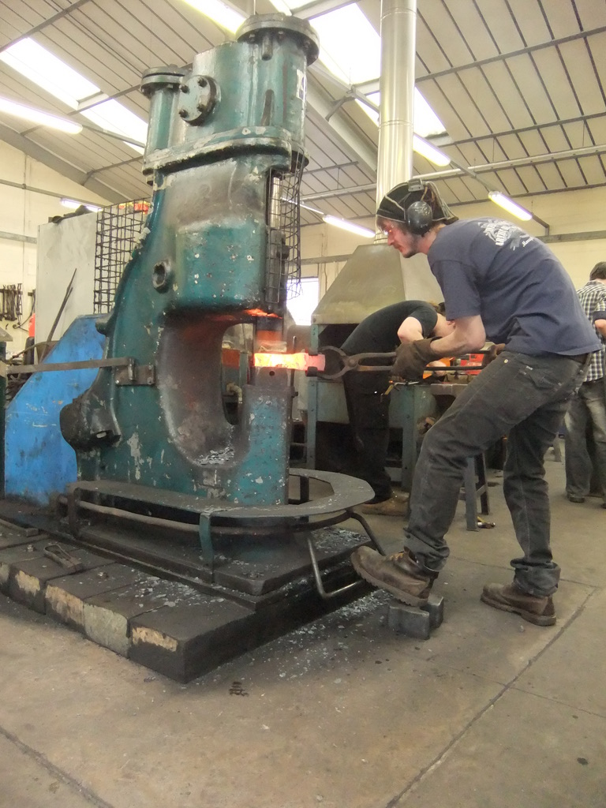
Whilst studying in Hereford, the term journeyman was being batted about and being used to describe ‘work experience’. There was progressive banter between a group of mates, all about different countries and workshops you had visited. It was a remarkable asset and a unique opportunity the craft had to offer. The ancestors of the blacksmithing trade had laid down the journeyman traditions, and since the medieval era, traveling workers had been developing in all different manners throughout Europe. From this, I believe an international language of blacksmithing was born. There are now smiths traveling for work from all over the world, and even though they might be landed in situations where there’s a language barrier, it’s possible to work it out with the language of the hammer and the anvil.
My journeymanship story started when I visited an Italian blacksmith, in 2011. I searched for work experience abroad on the original and very dysfunctional British Artist Blacksmith Associations website. I found contact details for smiths living in different parts of Europe and started to send them emails. Eventually I managed to organize a working holiday to Andrea Lori’s forge in the Valsugana Valleys, northern Italy. I had one year of training under my belt and was very green at the time. Thrown straight in at the deep end, we were making a long length of decorative forged railings. All the joinery was produced using traditional techniques. I remember Andrea telling me that if we could punch and drift the required holes as a smith and striker, then we were in effect working as fast as he could do it by himself on the powerhammer. This was intensive hard graft but gave me the opportunity to learn to swing a sledgehammer.
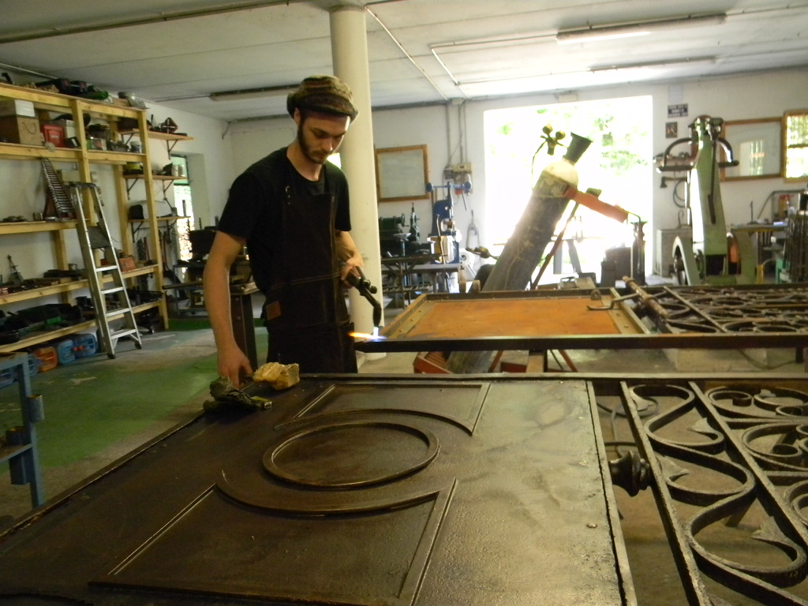
Over the next two months we worked in the same vein on various projects. I had to embrace my mistakes and his frustrations, but keep turning up and show willing. Being immersed in totally new surroundings was an eye opener. The hot summers meant we had to start work very early, siesta at midday and then work late into the evening. Andrea and his wife, Donatella, could only speak a small amount of English and I spoke no Italian, so we spent time during meals learning words from each other’s languages. The social dynamic was great, and I was getting along with the whole family, finding myself very much a part of normal day life in a rural Italian community. My most treasured memory was the time when Andrea drove us for a weekend trip to the world forging championship in Stia. Before the event, he decided that I should design a piece for the competition and gave me access to the large collection of blacksmithing books in his office. It was here I was introduced to a glimpse of the many masters and styles from all over the world. Taking inspiration, I came up with a plan and worked as his apprentice to create the sculpture at the event ‘The Show Must go on’. It symbolizes a continued form that ultimately has a beginning and an end, which can also be seen in the theme of evolution.
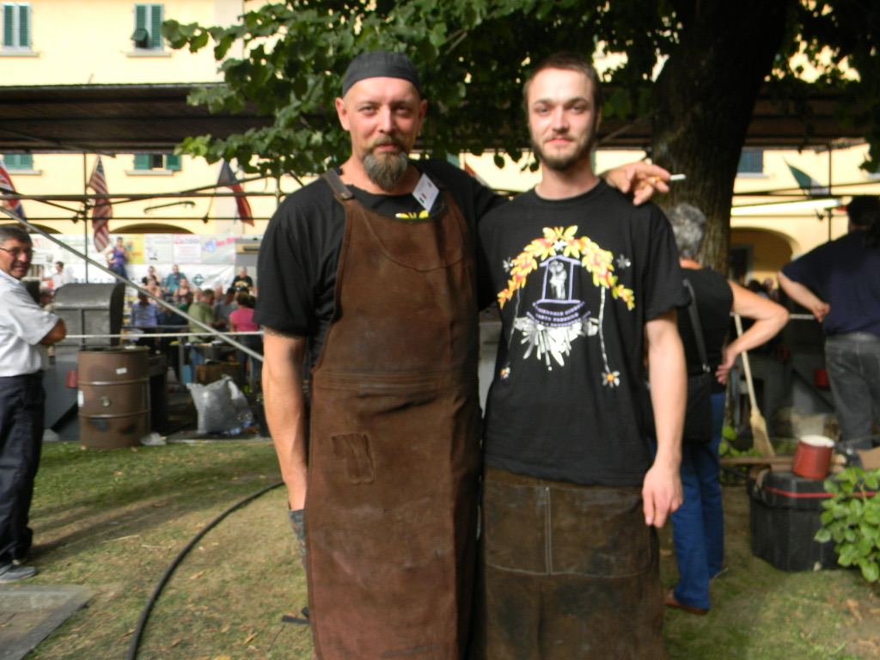
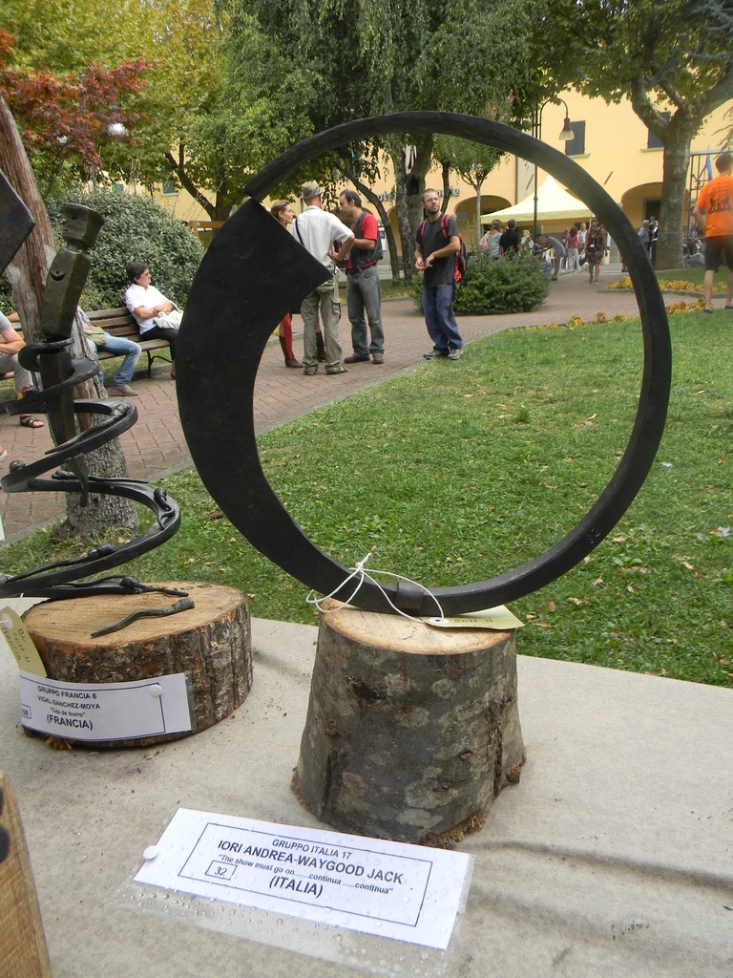
I’ve come to realise many of the elements that make this type of travel abroad work experience uniquely beneficial. In part, the initial action of organizing and moving yourself to and around another country builds on independence, bravery and confidence. Then by immersing yourself in someone else’s way of life, you need to be open-minded and easy-going to an extent. I find the best people I’ve met have traveled and they’re the kind of people who understand why we show gratitude and respect. That’s what traveling brings you; it’s positive character building. Aside from this, wider knowledge is gained in many aspects, such as trying to speak another language or trying new foods, and by exploring the country you become cultured. The most important thing is that if this experience is for you, then it’s hugely rewarding and fun.
In terms of working as a blacksmith, I asked myself questions such as, what type of work do I want to do? How long am I wanting to work for? Am I just looking for new skills and experiences or do I want full-time employment? The same questions applied when I was working abroad but maybe with more considerations based on the situation.
After completing my degree in Hereford, I had set up my own forge in the Brecon Beacons and also continued to study part-time on the Design and Forgework skills course. This training allowed me to refine my blacksmithing, focusing on purely traditional processes. In Brecon, I worked from an old shed on my cousin’s farm. I had a very basic setup which was cheap to run but brought about many challenges. After two years I had no regrets, but decided the situation had to change.
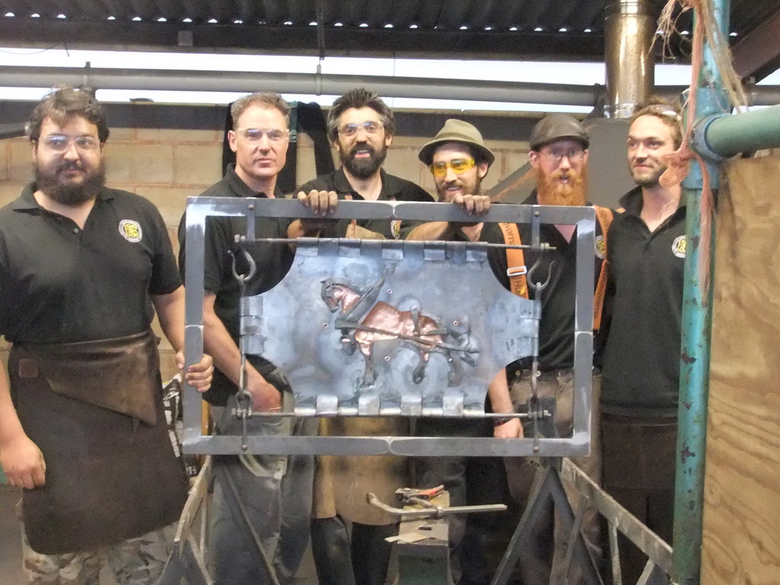
What did I want, I asked myself? I wanted adventure, I wanted to travel, and I wanted to do blacksmithing. I was influenced by my Finnish mate, Janne Peltokangas. He had been all over Europe with no more than a 15KG rucksack containing pants and his favourite tools, all made from titanium. At a blacksmithing festival in Ireland, I was hanging out with Janne and a group of other smiths who had all been working as full-time journeymen. I remember meeting these people and it giving me a real sense of their ambition to be highly skilled craftsmen, and the joy they were getting from this wild lifestyle. Events like this in Monaghan, Ireland, happen all around the world and make a great place for journeymen to network.
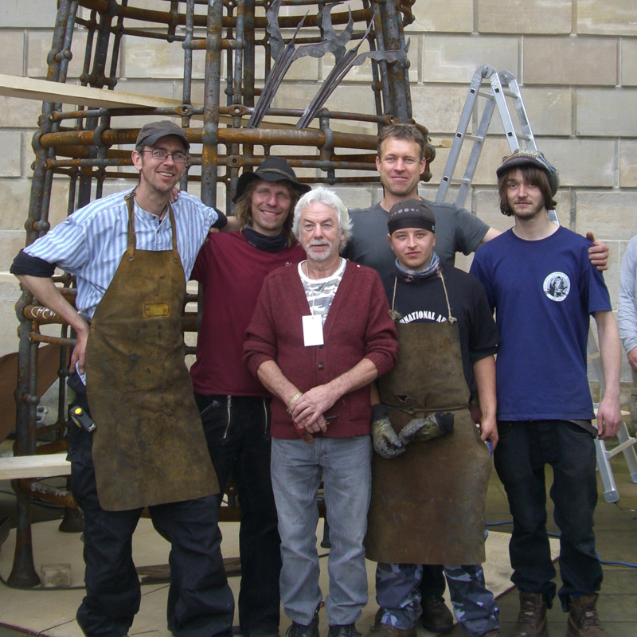
My new plan was to get about and see as many different approaches and workshops as possible. I immersed myself within the blacksmithing scene, and in the UK became an active member of the British Artist Blacksmith Associations. This is a great platform for bringing blacksmiths together to share laughs, wisdom and creating memories. I helped organize events, or ‘forge-ins’, and this made getting to know the people easy.

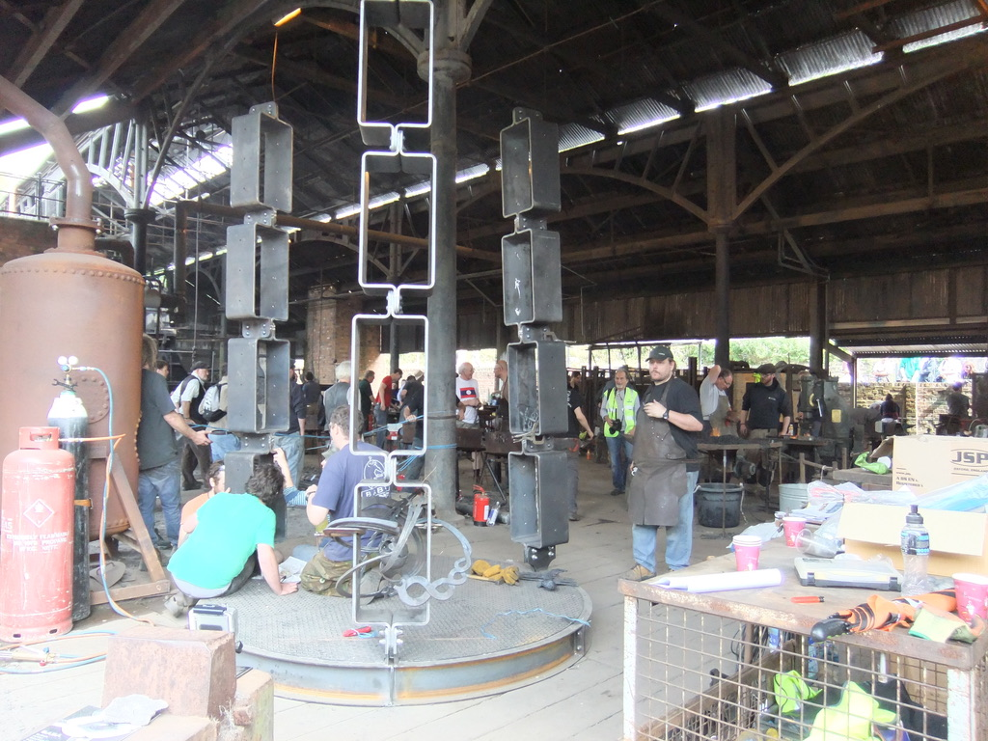
I kickstarted my journeymanship off once again by going back out to Italy. I traveled and worked in three different forges and reconnected with Andrea. After this trip abroad, I came back to the UK and spent the following year working short stints all over the country. Occasionally I would work back in Brecon, but on the whole it was quite a fluid experience and I got to work for the masters whose work I most respected. I had gained more understanding of the direction I wanted to take my skills and needed to ramp it up in the field of Architecture. I chose to settle in one place to focus on this aim and spent the next eighteen months fully employed at Iron Art in Bath. This situation suited me fine; I had money coming in and a ladder to climb. There was a lot of forging and I was in a prime position within the company to take on this aspect, had I stayed. Still in the back of my mind was the want to keep traveling and the only way to deal with that thought was to move forward.
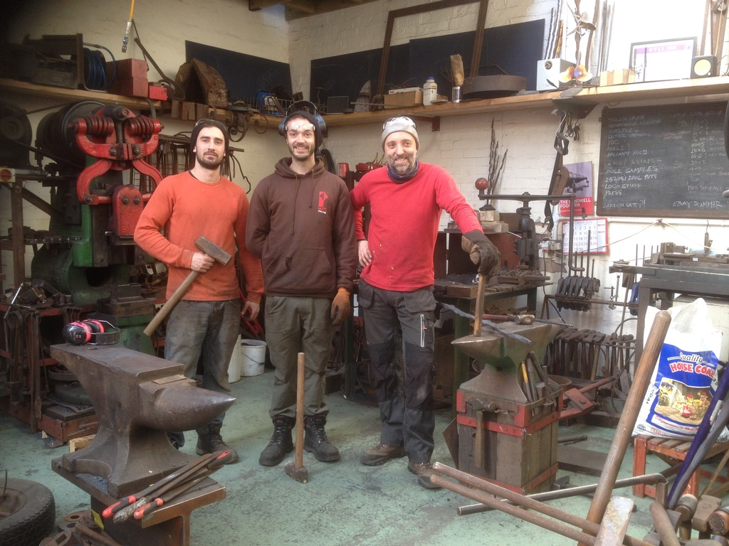
In 2018, I was awarded a Fellowship by The Winston Churchill Memorial Trust and the Queen Elizabeth Scholarship Trust award. The scholarships provided me the opportunity to journeyman around various countries in Europe. I wanted to explore further the different approaches to blacksmithing and focused on developing my own practice. Alongside this, my project would also aim towards giving exposure on journeymanships by sharing related information through BABA. This idea came to my attention when I realized that all the knowledge on the subject in the UK only exists as word of mouth. The reality of a journeymanship can be very difficult and challenging as a career choice, but by shining a light on this topic I hope to see the resources become more easily accessible and for some incredible stories to be shared and to inspire.
In the last ten years I have been witnessing the UK’s journeymen scene in its many contemporary forms. You have students traveling around on study breaks doing work experience. Professionals working in different forges, gaining knowledge before they set up their own shop. International journeymen working around the country, and smiths coming with a similar direction to myself. There’s no big historical tradition of journeymanships in the UK, and I’m not really concerned with trying to define the term or its parameters, however, from my perspective it’s simply a description of someone who has been traveling around working in order to learn new skills.
I have been contacting blacksmiths to provide me with a written article based on their travel and work experience, with the notion of having them published as a regular addition to the ‘Artist Blacksmith’ magazine. With a change of hands for the editorial position, my project was well received and will help to give the magazine a fresh new element during this transition. Currently I have eight completed articles and I’m really pleased by the variation of the results, from how working as journeymen impacted on their lives, to technical details such as how they found work and the jobs they were involved with. I’d really like to see this become a place where stories from a wider field can take place, sharing more information on artist blacksmithing and related interests from around the globe.
My next aim is to add a journeyman page to the BABA website. My initial thoughts are to create something similar to what ABANA (Artist Blacksmith Association of North America) have set up on their website, where you can read guidelines for journeymanships, related content and information. The following ideas could also be included and are up for discussion with the BABA council.
- An introduction to journeymanships with an overview of the current times.
- Etiquette and respect guidelines
- Travel guidelines, visas, vaccinations and languages.
- Funding, scholarships and grants.
- International associations and events links.
- Contacts: http://www.feblacksmith.com/links.htm.
- Making contact guidelines.
I handed in my notice and booked a flight to Stockholm, Sweden. The following day, I started a week-long course in axe forging at Gransfors Bruks. I then stayed and worked on before heading off to an industrial forge in Karlskoga. This was an instant eye opener, forging tools and axes to then working with a 500KG powerhammer and a large diesel furnace. I worked at another industrial forge in Trollhättan and then enrolled on a freestand at Steneby HDK, part of the University of Gothenburg.
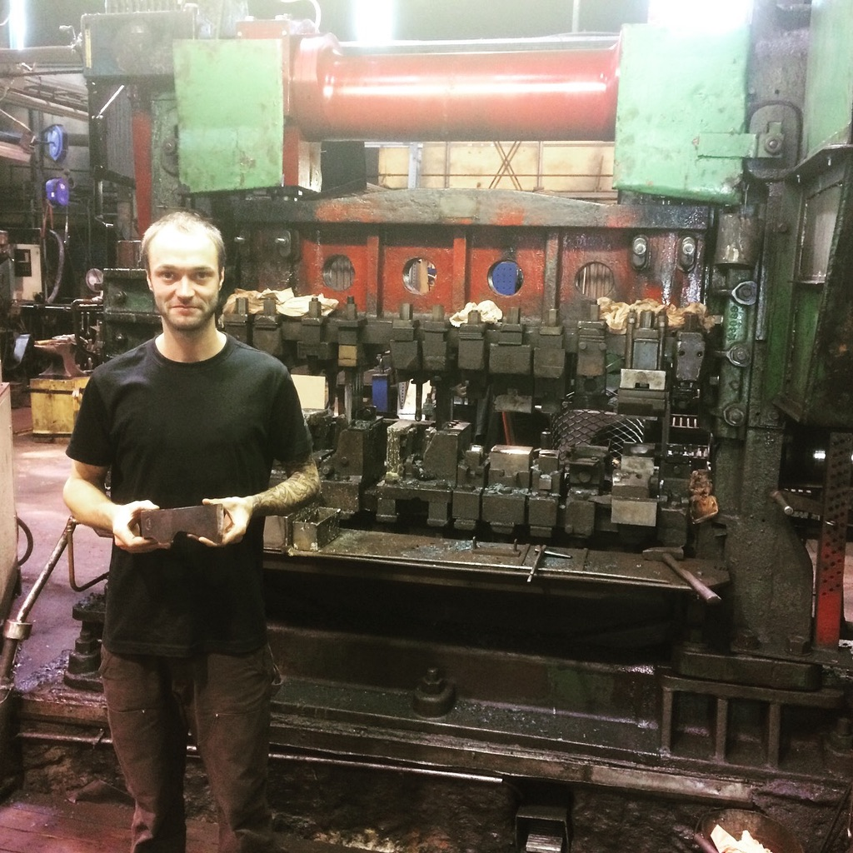

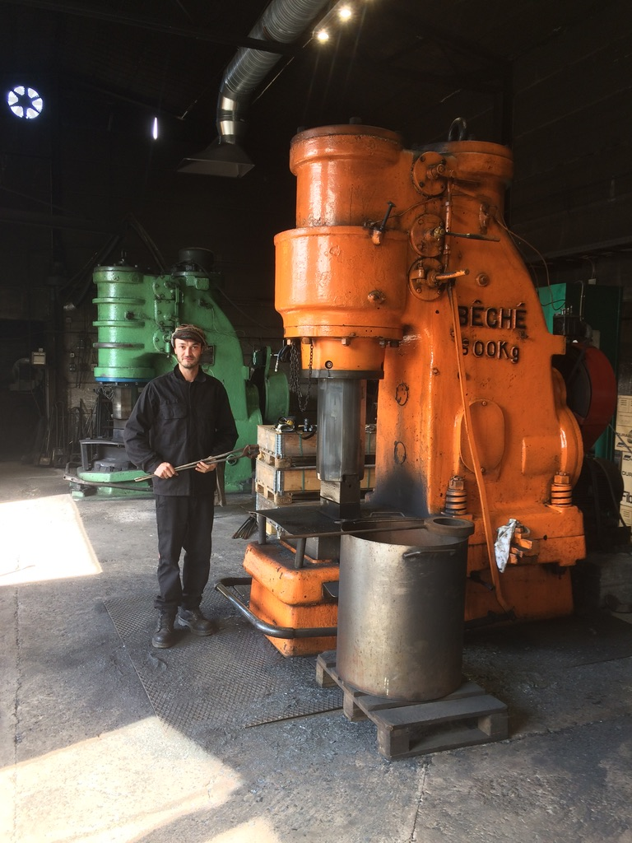

Steneby HDK is a cultural and creative environment that provides workshops and facilities for metal, wood and textiles. It is situated in a village called Dals Långed in the west of Sweden, where there’s an abundance of beautiful nature. I started a freestand course which gave me the time to work solo on my own brief. I started out by designing and making a range of hardware and saleable items. Within weeks, I turned my focus in a completely new direction towards art. I met a lot of artists and started to exhibit my own work as part of the Metal Art collective ‘Scale’. I was finding the whole experience very inspirational and took the opportunity to experiment and reconnect with my love for creativity. I originally planned to stay for four months but as the dark winter was moving in, I decided to extend my stay to a total of eight. I developed some strong work that I felt had real potential and wanted to put my energy into the contemporary art world, so I applied for, and was accepted onto, the Master’s degree in ‘Contemporary Art Practice’ in Edinburgh.
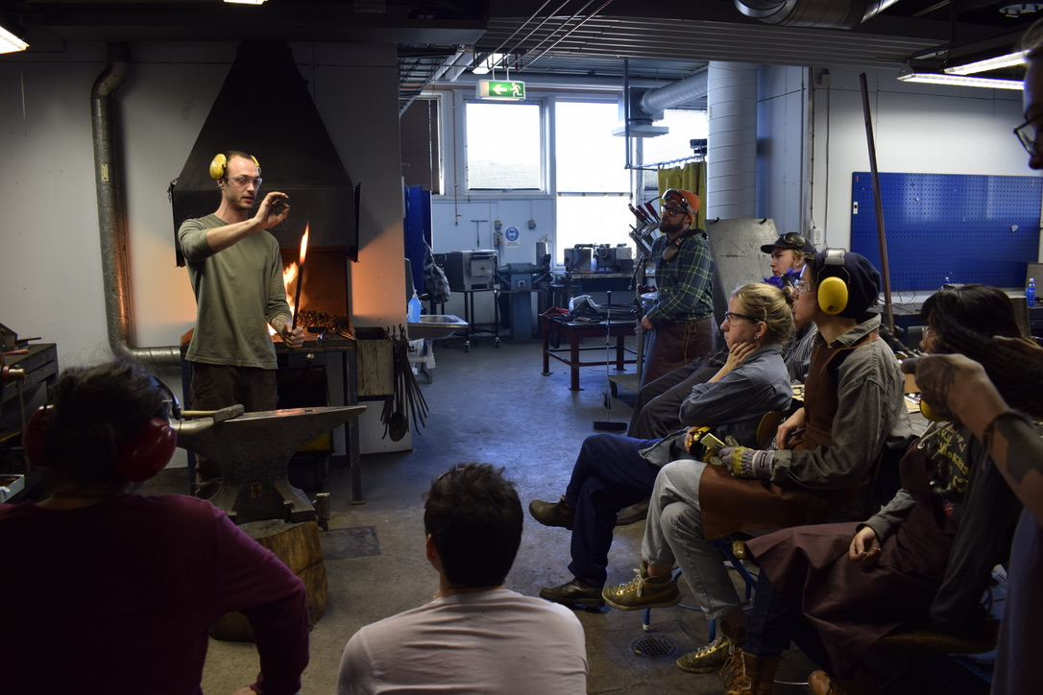
My time in Sweden ended with a study trip to Japan, which was funded by a scholarship that myself and a group of other students were awarded. We all went to Tokyo, then later I broke off and went exploring in Kyoto and Osaka. I managed to visit Sakai, which is home to the heart of Japanese sword smithing traditions and knife making.
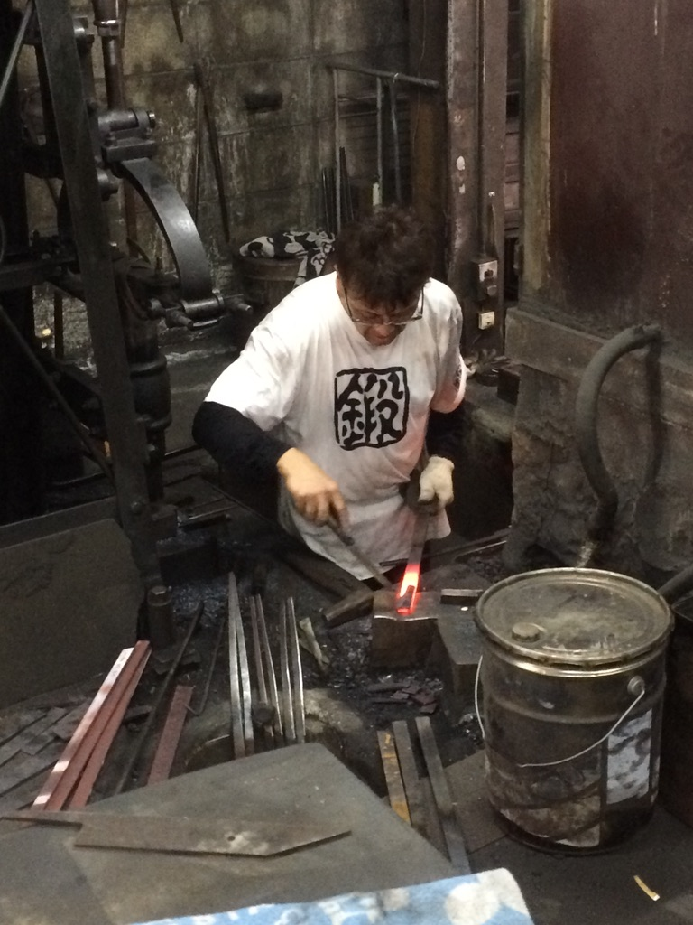
When I got back to Sweden, I was ready to hit the road in my transit van. I had made a plan which consisted of twelve forges which I could visit and work. I’d contacted them by email and made a variety of arrangements, trying to keep everything reasonably flexible and subject to change. Driving down through Denmark, I visited Copenhagen and went to see Kvindesmedien in the Anarchist commune of freetown Christiania. Next, I went to Berlin, then on to Prague, mainly visiting museums and sites of related interests. My Churchill Fellowship formally came into action when I arrived at Atelier Zimmermann in Stuttgart. I was given a warm welcome from Heiner and Paul, who have strong routes in upholding this traveling working tradition. They have hosted journeymen from all over the world and have utilized them in the function of running their business. It’s notable that not only the journeyman benefits from this situation. The host is also receiving different forms of benefit, such as having an extra pair of hands, skilled labour and someone with a positive attitude to work. It can be very useful for a company who don’t need a full-time employee but can bring someone in for a specific job or time period. It should also be a mutual exchange of social enjoyment which can build on motivation, inspiration and the opportunity to learn from one another. I listened to Heiner’s opinions on journeymanship factors and we also talked in depth about successful blacksmiths, contemporary art and business. I feel I learnt a lot from the discussions. I continued to collect and document this type of information throughout my travels. In turn I plan to use the resource to help formulate the results of the UK journeyman platform. I also learnt new techniques and gained a travel companion from my time at the Zimmermans. A mate of mine, Arttu Halkosari, had also been working while I was there and decided to join me on the next part of the journey.
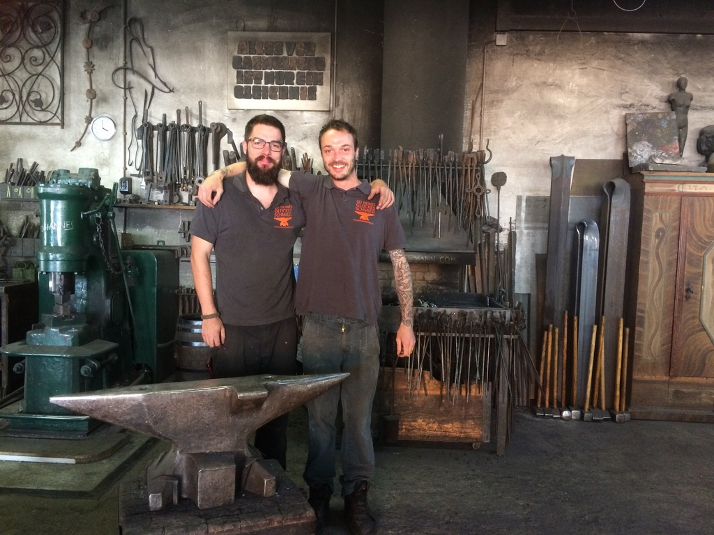
We made tracks to Nuremburg, where we would go and give Peter Bruner some helping hands. Peter had completed his training as a journeyman and gave me an insight into the traditions of how it worked in Germany. He also agreed to share this knowledge for an article in the magazine. We stayed two weeks and helped organize and take part in his blacksmithing festival, the ‘Hammer-In’. Here we met many smiths from all over Europe who were attending the event. I managed to make connections with smiths in Austria and organized the next location. Myself and Arttu got back on the road straight after the event to visit Sepp Eybl’s forge in Ybzits. This part of Austria has a long heritage in blacksmithing and ironwork, so we took some time out to study. We made a trip to the Kremayr museum, which had a section based on the traditional journeyman. We did a week with Sepp in his water-powered forge, then paid short visits to a number of other workshops within the region.
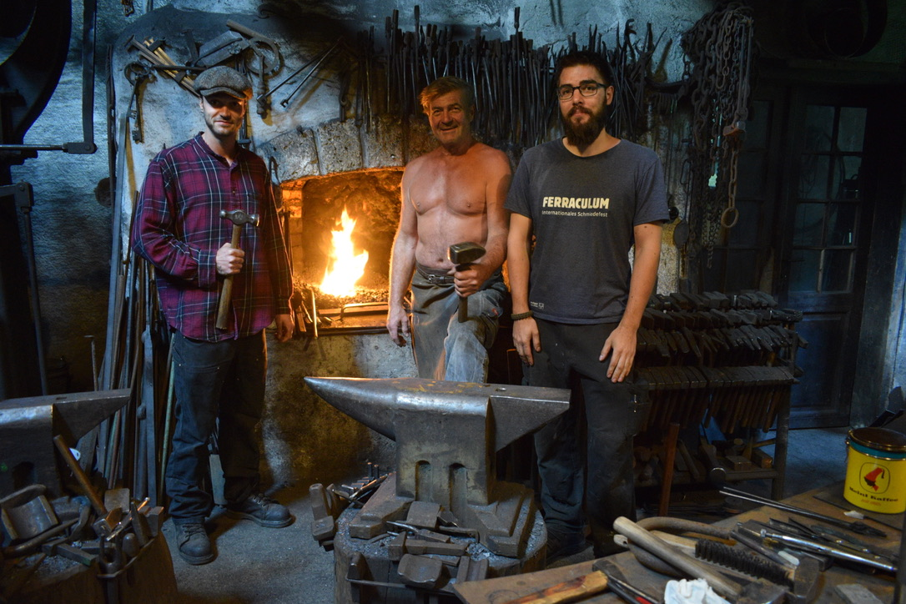
It was then time for the last trip on my Fellowship, and we headed north to Verona. We would spend a week working for the master blacksmith, Walfrid Huber. At the age of 83, he was an amazing presence and still a powerhouse on the forge. We watched him demonstrate how to make a flower he had designed thirty-seven years ago; it was a beautiful sight! In awe, we worked as hard as we could and had the opportunity to use the techniques we had been shown. Whilst in Verona, we also met up with another smith, Benjamin Stejskal. He shared with us his experience of traveling to Canada and working around as a journeyman over there. It was again another inspiring reason why I want these stories to be shared; it’s how our generation is doing this type of travel and work and the impact that it has on the individual.
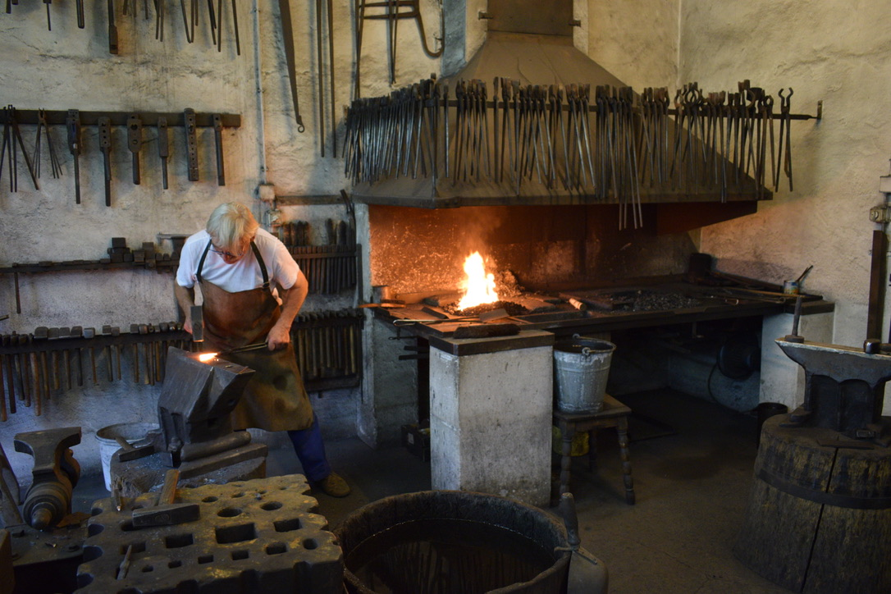

We had a few weeks left before the world forging championship in Stia. It felt like a long time since I was there the first time around with Andrea and he had unfortunately died the year before I set out for Sweden. This became an influence in my sculpture ‘infinity’, which was the last piece I made at Steneby HDK. It celebrates my ten years of blacksmithing and represents my path of learning from others, which is demonstrated symbolically within the piece. There is a ring on the left-hand side of the sculpture which represents ‘The Show Must go on’, made in 2011 at Stia by me and Andrea. A ring on the right-hand side was realized at Roberto Giordani’s forge in 2015. Roberto saw the piece me and Andrea had made and noticed that the railings we were working on had the same form but utilized a different process. The ring that links them all together is my own take on the idea of a continuous form, that ultimately has a beginning and an end. Central to the piece is the infinity mirror and candle which can be interpreted in many ways. I had decided to take the piece to Italy and had kept it stored away in my van. 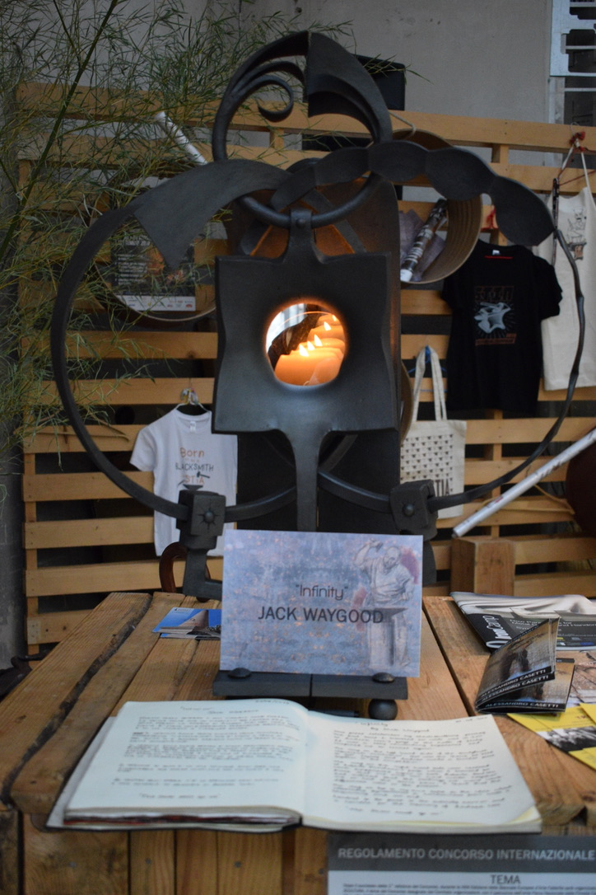

Setting off from Austria, we made our way down to Italy and stopped in three forges along the way. The first was at Christoph Küllinger, who was in south Austria, then Christop Friedrich in Switzerland. Finally, we arrived at Roberto Giordani’s in Marceto Scarachano. The next day, both myself and Arrtu had an early start on site installing a gate under the intense Tuscany sun. It had been four years since I had worked at Roberto’s and I was delighted to feel right back at home. Roberto contacted the organizers of the World Forging Championship and managed to pull a few strings in order to get my sculpture on display. On our final weekend, we headed over to Stia and the championships began. Myself and three friends entered the group competition as the first team from Finland. There is always great joy to be had at these types of events, especially when you can reconnect with people you haven’t seen in a long time. My piece, Infinity, was displayed in the exhibition and I received some very satisfying responses from my friends and shared an emotional but positive time with Donatella, Andrea’s widow.
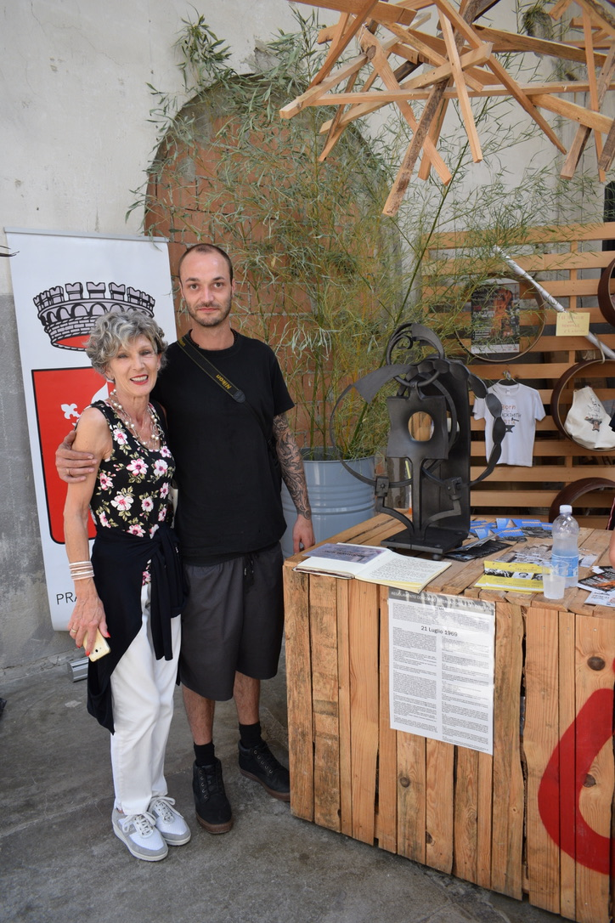
This is where my journeymanship ends for now. I remember someone saying how a Churchill Fellowship would change your life and I really didn’t think that was going to happen to me, but it did. My close family has expressed how much they think I have grown, and in myself I feel very complete with my journey so far. I also remember someone saying the Churchill Fellowship will open new doors and I didn’t think that would happen, but it did. Whilst working for Heiner Zimmerman, he turned to me one morning and made a passing comment about his mate, Jon Hall, who was looking for a blacksmith to work on a film set with him at his forge in New Zealand. I took that opportunity as if it was made for me, and now it’s on with the next chapter. I write this report form Cardiff, where I have been resting since my return. I will have been back in the UK for just two months before flying to the other side of the world to start my next job on the Lord of the Rings in Auckland.
My project is now in motion in the UK. I have lectured at Hereford College of Arts, sharing a presentation that portrays an overview of today’s journeyman scene, and demonstrating how people achieve this as a career choice. I have also sent in my words for an opening article in the ‘Artist Blacksmith magazine’. This explains my story and addresses the intentions for this project, backed up with three more articles from various journeymen that will hopefully give the readers a sense of what this platform is designed for. I have also presented the bigger task, which is now in the hands of the BABA Council, proposing the action of creating a ‘journeyman page’ on the website. I intend to keep control of this project and to move it forward in hope for its success.
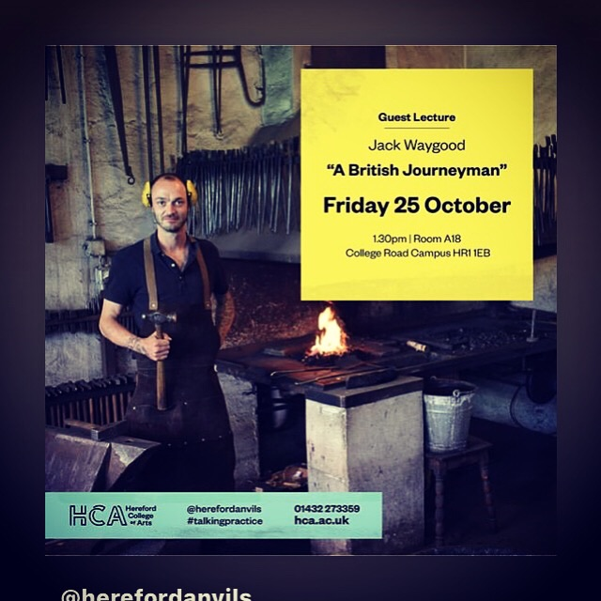
Thank you to all the people who have helped me by sharing knowledge and skills.
Special thanks to the following funders:
Winston Churchill Memorial Trust
Queen Elizabeth Scholarship Trust
British Artist Blacksmith Association - Education Fund
The Jinny Quinnell Memorial Trust

Copyright © [date of publication] by [name of author]. The moral right of the author has been asserted. The views and opinions expressed in this report and its content are those of the author and not of the Winston Churchill Memorial Trust or its partners, which have no responsibility or liability for any part of the report.

